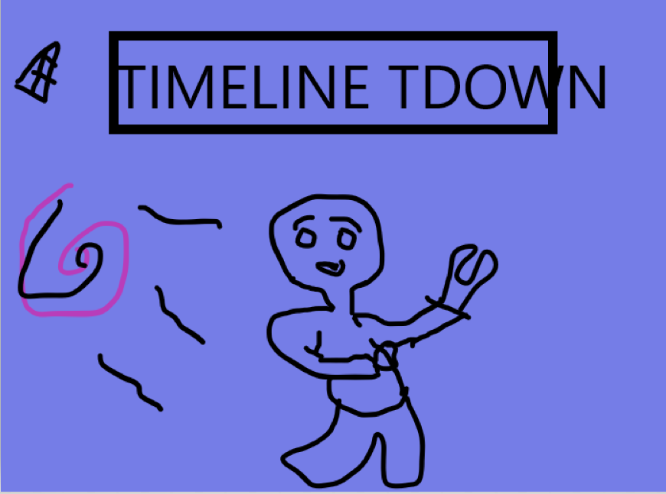

Main character in middle Running out the portal

Portal big in background

Maybe He is reaching for time part

Objects from the map in background such as chair from hospital and pyramid etc

- - - - -- - --- - -- - -- -- - - -- - - -- - -- -- - - - -- - --- - -- - -- -- - - -- - - -- - -- - - - - - -- - --- - -- - --

https://www.postermywall.com/index.php/posters/mine#/designs